Инструкция выполнения: Выполнить перевод текста «Gearbox». Выполненное задание предоставить преподавателю Королевой Александре Андреевне на адрес электронной почты. Эл.почта: evseeva14alex@gmail.com. Работа может быть выполнена в формате txt, doc, docx или фотография, выполненной работы на бумажном носителе.

«Gearbox»
Gearbox (also a gearbox, gearbox) - a mechanism used mainly in cars to change the gear ratio. The transmission element of wheeled and tracked vehicles, designed to expand the range of speed and torque of the engine used, the possibility of reverse movement, prolonged disconnection of the running engine from the transmission. By design, it usually is a separate unit, in the housing (crankcase) of which there are certain mechanical rotational gears that carry out multidirectional reduction of the power flow within a certain range of fixed gear ratios (gears) to choose from. In the case of an internal combustion engine, it is almost certainly part of the transmission, but can be replaced by a variator. As a rule, it is not used in transmissions of vehicles with steam or electric engines having high adaptability and hyperbolic (for steam) or parabolic (for DC motors) traction characteristic.
By the method of transmitting power flow:
Mechanical - gearboxes that use mechanical gears, usually gears. With coaxial shafts - made using cylindrical and bevel gears.
Planetary - made using planetary gears.
Hydromechanical - gearboxes in which mechanical gears, as a rule, planetary gears, are used in combination with a hydraulic gear (hydraulic coupling, torque converter).
CVTs are based on a stepless mechanical friction gear - a CVT, often in combination with a fluid coupling and planetary or simple gear drives.
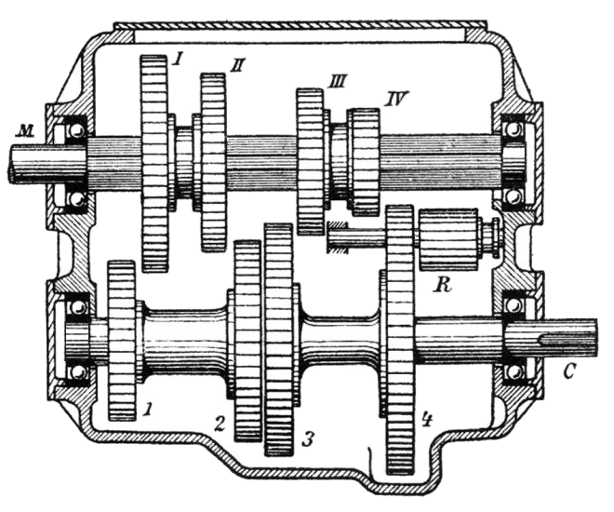
4-speed canonical gearbox

